
Update date, xx xxxx

Visa Debit Card Dispute Management
PROCESS

October 1, 2026

Document Tracking and Control Table

Policy Owner | TBC
Approval Date | TBC
Version | TBC
Access Level | TBC
Policy Author | TBC
Subject Matter Expert(s) | TBC
Last Full Review Date | TBC
Update Date (changes were made but a full review was not necessarily conducted) | TBC
Review Frequency Requirement | TBC
Changes made | TBC
Stakeholders Impacted | TBC

Purpose
The Visa Debit Card Dispute Management Procedure guides the Growth, Payment Services, Fraud Prevention, and Finance teams in managing member-initiated Visa Debit Card disputes. It sets out a consistent approach for receiving and triaging dispute claims, gathering and assessing supporting documentation, issuing provisional credit, submitting and managing disputes through Central 1 and the Visa network, and resolving disputes and recovering funds where applicable. It also covers the roles and systems involved, the process flows, and the detailed procedures across the dispute management lifecycle.

Scope
This procedure applies to all team members involved in the intake, triage, investigation, submission, and resolution of member-initiated Visa Debit Card disputes, received through the following channels:
- Branch: occurs when a member visits Beem’s branch to dispute a Visa Debit Card transaction.
- Contact Centre: occurs when a member contacts Beem’s Growth Team by phone to dispute a Visa Debit Card transaction.
This procedure covers the five stages of the dispute management lifecycle:
Stage 1. Dispute Intake
Stage 2. Dispute Triage
Stage 3a. Case Preparation & Document Assessment
Stage 3b. Provisional Credit Issuance
Stage 4. Network Submission & Response
Stage 5. Resolution & Recovery

Roles and Systems
The following roles and systems support various activities within the Visa Debit Card Dispute Management Procedure.
Role / System | Responsibility
Growth Team | Front-line contact centre and branch staff who maintain contact with members, receive the member's dispute claim, verify the cardholder and impacted transaction(s), records dispute details. Where required, they perform initial account security actions, such as blocking and reissuing the card.
Payment Services Team | Investigates and manages non-fraud (recognized/authorized transactions) disputes referred by the Growth Team, prepares case documentation, submits eligible disputes to Central 1, and manages dispute outcomes and recoveries for non-fraud cases.
Fraud Prevention Department | Fraud Management / Fraud Specialists provide centralized expertise and coordination to support consistent fraud detection, escalation, investigation, response, recovery, and reporting practices across the organization. They are responsible for leading or coordinating fraud investigations and case management activities, supporting appropriate evidence and documentation practices, and enabling effective cross-functional coordination and governance visibility for significant fraud risks, trends, and incidents.  Key responsibilities may include:  - conducting or coordinating fraud investigations and case management activities,  - maintaining case documentation and supporting appropriate evidence handling practices,  - coordinating escalation, response, containment, and recovery activities with relevant operational and support functions,  - supporting reimbursement and remediation activities in accordance with established guidelines and approvals,  - monitoring fraud trends, emerging risks, and typologies to inform detection and control improvement opportunities,  - supporting fraud reporting, analytics, and governance visibility into material incidents and trends,  - providing operational guidance and input into training and awareness materials,  - coordinating with external parties (e.g., law enforcement, insurers, payment networks) where appropriate.
Finance Team | Validates and posts provisional credit to the member's account within pre-defined SLAs, tracks provisional credit aging and reversal, finalizes or reverses provisional credit based on the dispute outcome, and records recoveries, losses, fees, and general ledger entries.
Central 1 | Beem's financial services partner that receives completed dispute submissions and routes them, via PPJV, to the FIS Everlink Settlement team for submission to Visa Resolve Online (VROL) on Beem's behalf.
FIS Everlink (Everlink) | Beem's Visa Debit program processor. Submits dispute requests to Visa on Beem's behalf via VROL, and manages the pre-arbitration and arbitration cycle in accordance with Visa Rules and pre-defined processes and timelines.
CRM (Dynamics 365) | System of record used to create and track dispute cases and trigger both the ATM/POS trace (non-fraud) and Fraud Intake Form (FIF) (fraud) workflows.
DNA | Beem's core banking system used to review member and account information and apply card or account restrictions.

Stage 2: Dispute Triage Process (Payment Services / Fraud)

5.1 Process Flow
The visual overview below provides the end-to-end process for triaging a dispute case handed off from Growth. This stage is owned by the Payment Services Team / Fraud Prevention Department.
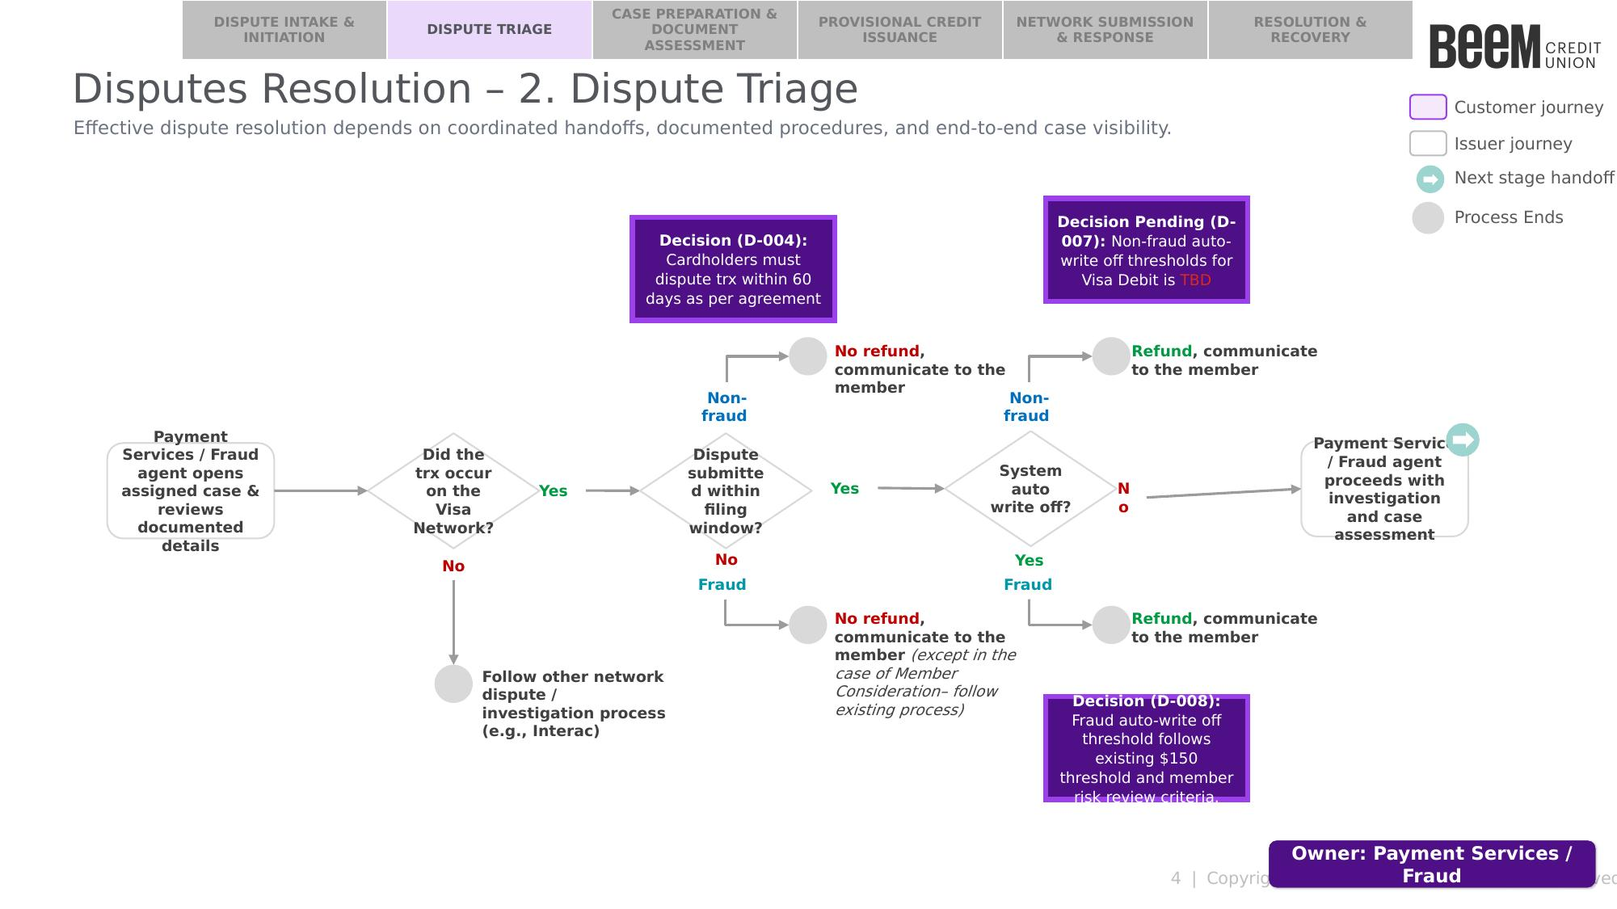

5.2 Procedure
The following procedure provides a step-by-step outline of the activities performed by the assigned Payment Services or Fraud agent as part of dispute triage.

5.2.1 Open the Case and Confirm Completeness
Upon opening the assigned case, the agent should review the documented details received from Growth and:
- Confirm whether the disputed transaction occurred on the Visa Network, as indicated by the network type captured in the Transaction Details field of the CRM case.
  - If the transaction did not occur on the Visa Network: follow the applicable other network dispute / investigation process (e.g., Interac). This procedure ends.
  - If the transaction occurred on the Visa Network: proceed to Step 2.
- Confirm the case was correctly classified, and that the case documentation was completed correctly:
  - Fraud Prevention Department: confirm the dispute narrative and case details support a fraud classification, and that the Fraud Intake Form (FIF) was fields were completed accurately and proceed to Section 5.2.2 — Fraud Team: Assess Filing Window and Auto Write-Off.
  - Payment Services Team: confirm the dispute narrative and case details support a non-fraud classification, and that the ATM/POS Trace Request fields were completed accurately and proceed to Section 5.2.3 — Payment Services Team: Assess Filing Window and Auto Write-Off.

5.2.2 Fraud Team: Assess Filing Window and Auto Write-Off
- Assess filing window: the Fraud Specialist should assess whether the dispute was submitted within the filing window — members must dispute a transaction within 60 days of the transaction date, as per cardholder agreement.
- If the dispute was not submitted within the filing window: no refund, except in the case of Member Consideration — please refer to the Fraud Reimbursement Guidelines. The Fraud Specialist should then:
    - Document the rationale for the refund decision in the CRM case notes then proceed to step B.
    - Close the case by setting the CRM case status to “Closed”, which notifies the Growth team member who opened the case of the case closure. This procedure ends.
- If the dispute was submitted within the filing window: proceed to Step 2 — Assess auto write-off.
- Assess auto write-off: the Fraud Specialist should assess whether the dispute qualifies for a system auto write-off — the fraud auto write-off threshold is $150; disputes at or below this threshold qualify for auto write-off.
  - If the dispute amount is at or below $150: refund and communicate to the member, and set the CRM case status to “Qualify for Auto-Write Off”, which routes the case back to the Growth team. This procedure ends.
  - If the dispute amount is above $150: proceed with investigation and case assessment — see Stage 3A: Case Preparation & Document Assessment, and refer to the Visa Debit Card Fraud Investigation Process.

5.2.3 Payment Services Team: Assess Filing Window and Auto Write-Off
- Assess filing window: the Payment Services agent should assess whether the dispute was submitted within the filing window — members must dispute a transaction within 60 days of the transaction date, as per cardholder agreement.
  - If the dispute was not submitted within the filing window: no refund. The Payment Services Team member should then:
- Document the rationale for the no-refund decision in the CRM case notes then proceed to step B.
- Close the case by setting the CRM case status to “Closed”, which notifies the Growth team member who opened the case of the case closure. This procedure ends.
  - If the dispute was submitted within the filing window: proceed to Step 2 — Assess auto write-off.
- Assess auto write-off: the Payment Services agent should assess whether the dispute qualifies for a system auto write-off — the non-fraud auto write-off threshold for Visa Debit is TBD.
  - If the dispute amount is at or below the threshold: refund and communicate to the member, and set the CRM case status to “Qualify for Auto-Write Off”, which routes the case back to the Growth team. This procedure ends.
  - If the dispute amount is above the threshold: proceed with investigation and case assessment — see Stage 3A: Case Preparation & Document Assessment.

